

Appointment of the

Head of the School of Media, Music and Film

Contents

- Welcome from the Dean of College

- The College of Arts and Humanities

- Research and impact in the College of Arts and Humanities

- The Role

- The Person

- Working at the University of Brighton

- University Life

- How to apply

- Submission of Applications

Welcome from the Dean of College

Thank you for your interest in this important leadership role at the University of Brighton.

In 2014 the University established a new three-college system comprising a College of Arts & Humanities, a College of Social Sciences and a College of Life, Health & Physical Sciences

The College of Arts & Humanities is a creative environment with a unique portfolio that encompasses the visual and performing arts, architecture, design and urbanism, media, music and film and the humanities; bringing together the rigours of disciplinary research and critical scholarly traditions with creative, professional, interdisciplinary and practice-based knowledge.

Through the continual questioning of our understanding, histories and knowledge of the human condition, human experience and human potential, our core mission is to develop creative, socially purposeful leaders with the critical confidence to innovate, think and act differently, challenge conventions, take risks, and develop new ways to communicate and interpret what we think, read, see and hear. Our mission is to enhance human dignity and identity, social justice and the elegance of life-lived, through questioning the contribution of the arts and humanities to health and wellbeing, to rethinking the value of creative work, play and partnerships and to transforming how we govern, encounter and experience the intersections of civic and digital environments and artefacts in the world.

Built upon three strategic pillars of Excellence, Innovation and Enhancement, our established international partnerships position the College as a partner of choice enmeshed within a rich mix of cultural, social and economic networks. These networks underpin our relationships with professional bodies and are strengthened by our staff and students working and researching together as a single learning community, to understand how disciplinary, subject and professional knowledge is formed, questioned, valued and communicated.

With a distinguished tradition in integrating teaching, learning, research and enterprise facilitating perpetual knowledge exchange, the college community makes a significant contribution to regional prosperity, in thinking through how we know, listen and live better together and navigate an uncertain world marked by rapid change, conflict, interdependencies, transformative technologies and multi-modal communications.

At this important moment of change for the College we are keen to appoint three inspirational and motivated leaders to lead the formation and future development of three newly created schools that broadly encompass distinctive subject clusters: “Architecture, Design and Urbanism”, “Arts and Applied Arts” and “Media, Music and Film”.

These roles offer opportunities for three outstanding and visionary leaders to shape the future of these subject clusters and to contribute to the College and to the University’s strategic objectives to be a contemporary sector leader in transformational learning, applied research, economic and social engagement.

We appreciate your interest in these important leadership roles and sincerely hope you will be encouraged to make an application for one of these positions. If you would like to discuss these roles further please do not hesitate to contact me.

Anne Boddington, Dean of College
Arts & Humanities
Email: a.boddington@brighton.ac.uk telephone: 0044 1273 643005
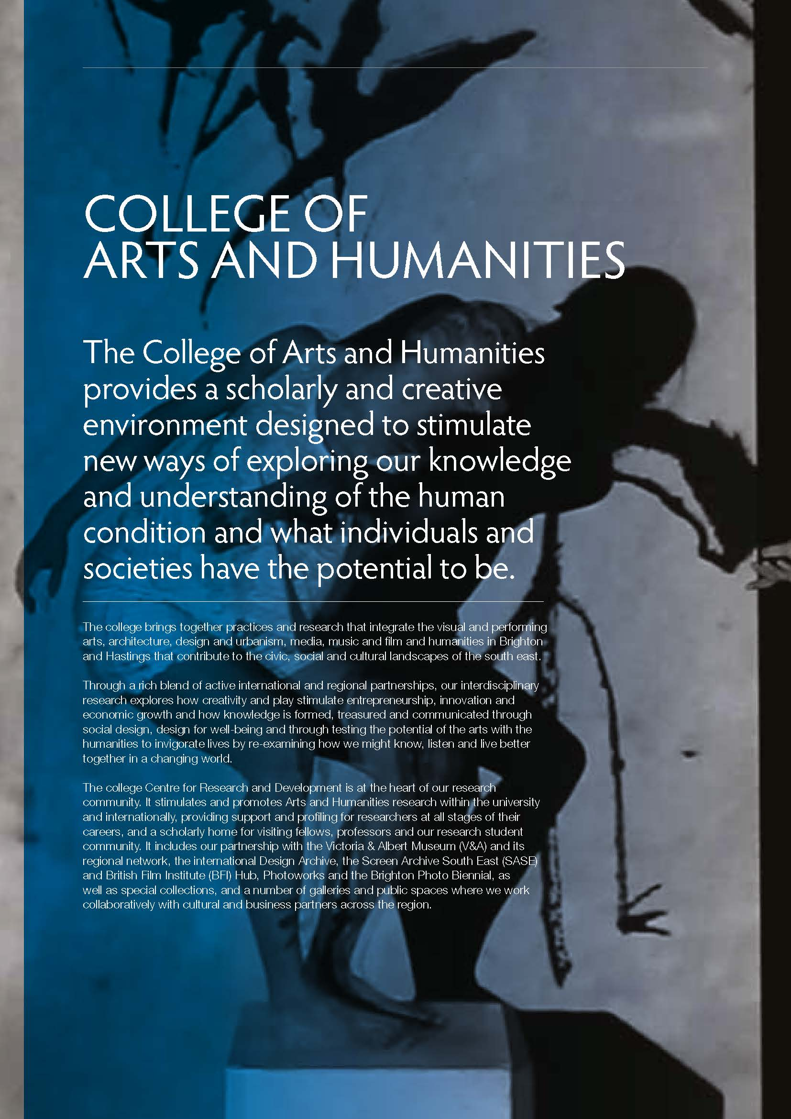

Research and Impact in the College of Arts & Humanities

The College of Arts and Humanities has a well-established Centre for Research and Development (CRD) that provides the scholarly, intellectual and operational infrastructure for leading and supporting compelling ideas, research development, grant initiation, development and quality across the College, including career development and profiling and an integrated infrastructure for supporting regional and international pathways to capture impact through economic, industry and social engagement and partnerships. Co-located with the Doctoral Centre and the Brighton Doctoral College, the CRD also provides a physical home and social nexus for all doctoral students.

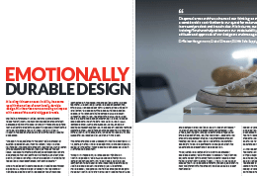 | A leading thinker on sustainability has come up with the notion of emotionally durable design. His theories are now making an impact with some of the world’s biggest brands.
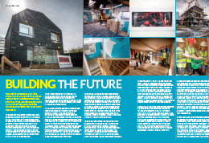 | How do you create sustainable urban living? University of Brighton researchers have developed high-profile ways to promote sustainable living, which have captured the imagination of both their peers and the public.
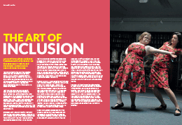 | University of Brighton academics have been pushing the boundaries that separate art and life, and developing a more inclusive approach to performance.
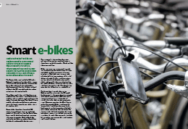 | Media technology and design are being used to inform social and environmental issues at the University of Brighton, where research is providing new understanding of how commuters and communities use bicycles, a sustainable mode of transport.
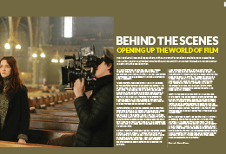 | We live digital lives and researchers at the University of Brighton are helping to make those lives richer, exploiting the best of what the online world has to offer through an intricate set of insights into the world of film.
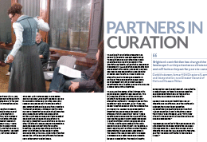 | The Victoria and Albert Museum is the world’s greatest museum of art and design, and for nearly 20 years researchers from the University of Brighton have helped transform the Museum’s role in shaping contemporary design cultures.
 | Brighton has provided a moving past for the region, the nation and beyond. There are many ways of accessing the past but moving images offer a unique insight into how we lived our lives during the twentieth century. One of the University of Brighton’s leading art and film historians has been instrumental in opening up the world of film through Screen Archive South East.
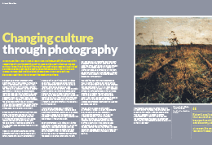 | Drawing on their international reputation in photography, the university’s researchers have changed the way images can be used to help us engage with our history and identity. From playing a key role in reconciling divided communities to creating the way public projects such as the Millennium Dome are recorded and displayed, these innovative practices have demonstrated the cultural impact the medium can have.

The Role

We are looking to recruit a high calibre, inspirational and self-motivated individual to lead the future development of the School of Media, Music and Film

The academic structure at the University of Brighton comprises three Colleges; Life Health and Physical Sciences; Social Science and Arts & Humanities. The Colleges form the overarching intellectual framework of the University and each College hosts a Centre for Research and Development (CRD) that provides a supporting infrastructure for research, doctoral study and public engagement. Schools form the core teaching and subject clusters of the University and are the units through which students and academic delivery is developed, planned and managed. Each College is led by a Dean, supported by a Director of Research and Development, and the Heads of each of the Schools within the College. Schools are the core structures for the planning and delivery of subjects, student experience and for the integration and highest international standards in research production, teaching, learning and public engagement.

The role of the Head of School
Heads of School are primarily responsible for the leadership and development of the academic disciplines and professions in their School and are the senior managers of both the human and physical resources. Responsible to the Dean for ensuring University policies are implemented within their school, they also contribute to the College leadership and each Head will have a cross-college portfolio and are expected to engage in wider university initiatives and positioning the university internationally. Supported by a School Administrative Manager, Heads are supported by a management sub-structure appropriate to the delivery of the School’s portfolio and its requisite academic and professional requirements.

Specific responsibilities include:

Strategic and Academic Leadership

- Working with colleagues across the college and the university to develop and deliver the university school and college vision and underpinning strategies to advance the universities reputation and success
- Working with the Dean and Centres for Research and Development to develop and foster the highest quality research and engagement cultures across the university
- Developing and delivering school plans consistent with university policies with specific reference to student experience, curriculum development, pedagogic innovation, research outputs and income generation
- Driving the development of the academic portfolio.

Quality Assurance and Enhancement
The Head of School is responsible for the delivery of an enhancement-led quality assurance framework as applied to its portfolio. Central to its delivery will be:

- Chairing the School Board
- Appointment of the highest quality staff and their performance, development, welfare and wellbeing
- Meeting recruitment, progression, retention and DLHE targets and ensuring the continuous development of the student experience
- Working with academic and professional services to ensure rigorous systematic enhancement and assurance frameworks are maintained at all times
- Ensuring effective influence with subject and professional bodies, managing annual academic health reports and developing a clear strategy for QAE linked to the school and college.

Management

- Chairing the School Management Group
- Working with the Dean of College to build leadership and management capacity and a collegiate approach to teamwork within the school management structures
- Working with the School Management Group to ensure the equitable allocation of duties according to university workload planning agreements and managing the planning of sabbatical leave
- Working with senior staff to ensure the school has a clear approach to equalities which is in accordance with the university’s wider strategic agenda.
- Working the senior staff to manage the strategic allocation of budgets and resources within the university’s financial regulatory frameworks.
- Managing health and safety issues for the school
- Driving the implementation and development of the Teaching Excellence Framework within the school

Leadership and Career Development

- To build leadership and career development, through deputising for the Dean of College and contributing to the leadership and positioning of the College by conducting College and university-wide duties as agreed with the Dean
- Maintaining personal and professional activity in areas such as research, teaching and economic and social engagement.

Performance

Heads of School report to the Dean of College and their performance is managed according to an agreed set of indicators identified between the Dean and the respective Head of School which are based on a common framework.

The Head of School is directly responsible for the quality performance of the School and its academic and support community as a whole and specifically for the performance of its senior staff. This will be based on a clear set of identified accountabilities.

The Person

The successful candidate will be able to demonstrate the following qualifications and qualities, particularly in relation to the principal areas of work of the school:

- A record of significant research and/or professional achievement and international standing in one of the aspects of the school’s provision
- Effective leadership, management, interpersonal and communication skills and evidence of successful external engagement and the development of a community of staff
- A broad understanding and knowledge of the school’s principal disciplines, subjects and professional fields
- The demonstrable ability to think and plan creatively and strategically and to successfully realise strategies that integrate and advance quality teaching and learning, research, economic and social engagement
- The ability to develop mutually beneficial and effective partnerships, productive collaborations and influential relationships with external professional bodies and research councils
- An aspiration, ambition and vision for the advancement of innovative, high quality learning and teaching, research and its impact, economic and social engagement
- Demonstrable experience of developing strategies for the generation of external income and the management of external contracts
- An understanding and commitment to enhancing the student experience.

Benefits of working at the University of Brighton

You will be joining a university with 2,600 staff and 22,000 students with campuses based in Brighton, Eastbourne and Hastings.

Staff benefits:
- Childcare vouchers
- Cycle to Work Scheme
- University Nurseries close to campus
- Wide ranging staff development opportunities
- Maternity, paternity and adoption schemes providing enhanced payments
- Defined benefits pension scheme
- Staff car parking at campus sites
- Season ticket loans for buses and trains
- Christmas / New Year closure
- Occupational health, welfare and counselling services
- Concessionary membership of university sports facilities

Salary
Salaries for senior management posts are determined by the Vice-Chancellor, and reviewed annually. The salary for this post will be within the range £75,854 to £80,465 on current values.

Job Sharing
The University of Brighton welcomes job sharers although appointment as a job share is dependent upon the two most suitable candidates for a post wanting to share. If you want to apply as a job sharer, please indicate this in your application.

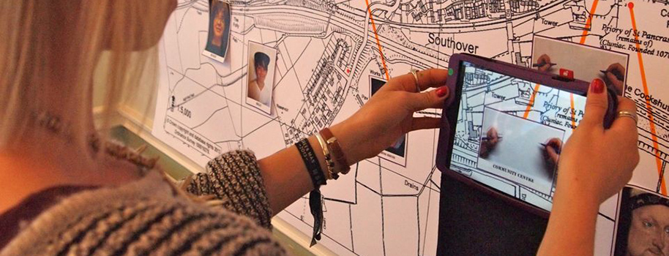

Hours of Work
This post is full time. The nature of senior posts is such that staff are expected to work such hours as are reasonably necessary in order to fulfil their duties and responsibilities. It would therefore be inappropriate to define the total hours to be worked in any week.

A reasonable norm for full-time staff, however, having regard to the contractual position of other senior staff in the institution, would be 37, although this should not be regarded as a minimum or maximum.

Holidays
The annual leave entitlement for full time staff in this post is 30 working days. This is in addition to statutory holidays, local discretionary holidays and days when the university is closed in the interests of efficiency.

Terms and conditions
In determining terms and conditions of employment, the university has regard to recommendations made through the appropriate national negotiating framework.

These terms and conditions of service can be varied by local agreements reached through the university’s local negotiating framework which comprises a Joint Negotiating Committee supported by two Common Interest Groups. These groups bring together representatives of the university and its recognised trade unions, which are:
• UCU – University and College Union
• UNISON.

Relocation
Although there is no specific limit on the distance from the university within which members of staff are expected to live, it is nevertheless expected that they will live within reasonable travelling distance.

The purpose of this requirement is not only to ensure the effective discharge of responsibilities but also to offer some assurance that the colleague concerned is not prevented from playing a full part in the life of the university and the local community.

The university offers financial assistance with relocation to Brighton subject to certain conditions being met. Further information will be supplied to the successful candidate.

Professional Development
Four part-time courses are run within the university for staff new to the teaching role. In addition to these courses for staff new to the teaching role, the Centre for Learning and Teaching offers a wide range of courses, events and consultancy to experienced lecturers and to course teams and academic schools across the university. Further information is available from the CLT’s website: www.brighton.ac.uk/clt/.

Sustainability
The university is committed to sustainable development and is ranked third of 145 universities in the 2012 People and Planet Green League. We are unique amongst
universities in having an ambitious target to reduce carbon emissions by 50% between 2011 and 2016 through our c-change programme. We look to incorporate sustainable development in all we do, from carbon reduction, procurement processes and the work of staff and students.

University Life

Each town has lots of opportunities to get involved in its culture and community – offering something for everyone and a great place to progress and live.

Brighton
Brighton is vibrant, colourful and creative with a reputation for freethinking and for valuing all different cultures. It is known for its exciting cultural and social life.

The city hosts the largest arts and culture festival in England – the Brighton Festival - along with a number of other events, such as the Brighton Science Festival, Pride, Burning the Clocks, the London to Brighton Bike Ride, the Brighton Food Festival and the Brighton Marathon.

Brighton offers a hotbed of festivals, galleries, museums, film, nightlife, comedy and theatre. It has a wide and varied range of shops, from the high street to the famous Brighton Lanes.
Eastbourne
Considered the sunniest place in the UK, Eastbourne is a lively seaside town surrounded by beautiful countryside.

There is a wide variety of restaurants, cafes, traditional pubs, wine bars and nightclubs in the town, along with many sporting and cultural activities.

Sports range from golf to horse riding, with water sports such as sailing, canoeing, body boarding, windsurfing and power boating all very popular.

Four theatres, two cinemas, four shopping centres, and the Towner contemporary art museum for Southeast England, are all within walking distance of our campus.

The UK’s largest free air show in August and the annual extreme sports festival attract hordes of visitors to the town each year.
Eastbourne also boasts two pre-Wimbledon tennis tournaments.
Hastings
Hastings is an historic and beautiful town with a vibrant arts and live music scene. It is home to the largest beach-launched fishing fleet in Europe, the remains of the first castle in England to be built by William the Conqueror, a preserved Old Town and a strong local arts community.

The Old Town, to the east, is a mix of half-timbered houses, narrow streets and passageways, locally known as twittens. To the west is St Leonards which features the classical elegance of James Burton’s architecture.

Hastings is home to the Jerwood Gallery, which is the new public home to the Jerwood Foundation’s collection of twentieth and twenty-first century British Art. Annual events in Hastings include Hastings Day, Jack in the Green and Pirate day. The Hastings Seafood and Wine Festival is a celebration of Hastings sustainable fishery and fishing heritage, its surrounding vineyards and excellent local food producers.

How to apply

The appointment process
Applicants are invited to complete applications including their personal details and equal opportunities monitoring data on the university’s online recruitment system.

In addition you are asked to submit a curriculum vitae, complete the supporting statement sections of the online application form, and to nominate two referees (names, positions and addresses) who are able to comment on the applicant’s suitability for the position, one of whom should be the current or most recent employer.

Curriculum vitae
Curriculum vitae should contain at least the following details, preferably in the order stated below.

Personal details
Name, title if used, post nominals, date of birth, home and office addresses and telephone numbers, any requirement for a work permit

Present employment
Title of post, brief job details, grade and salary, commencing date, period of notice required.

Higher education
Name of institution(s) and dates attended, full- or part-time attendance, subjects studied, qualifications gained.

Institutional or professional membership
Involvement, institution(s) and date(s) of admission, class of membership

Employment history
Employment history should be in chronological order. If periods of employment are not consecutive it would be helpful if details of activity in the intervening period (e.g. periods of full-time study) could be included.

For each employment the following information should be given: employer, post title, brief description of post, commencing and finishing dates

Professional activity
Description of any relevant external professional engagement, including consultancy, research or publications

Research and publications
Details of publications, research grants obtained including investigator status, conference papers, other presentations, research students supervised

Supporting statement
In the supporting statement, applicants should
set out how their qualifications, qualities and
experience fit them for the post, relating these to
the role description and person specification above.

References
References may be taken up on any candidate prior to final interview, unless subject to an express request not to do so, in which case this should be made perfectly clear as part of the application.

Professorship
Suitable candidates may be eligible for the conferment of the title of Professor. Professorial titles are awarded against the criteria set out in the document ‘Professorial Bands and Criteria’ which may be downloaded from the online recruitment system.
Candidates may apply for a Professorial title as part of the application for this post or may decide to apply subsequently, if appointed. If applying as part of the application for this post, a separate statement showing how they meet the criteria for any of the professorial bands must be submitted.

Publicity
The university will deal initially with all enquiries and applications on a confidential basis. However, the selection process will be a relatively open one, in which shortlisted candidates will be given the opportunity to meet a range of university staff. Whilst the shortlist will not be explicitly published outside the university, it is anticipated that knowledge of who is on the shortlist will become public.

Equal opportunities
All applicants are requested to complete the university’s monitoring form.

Submission of applications

Applications including curriculum vitae and supporting statement should be submitted via the university’s online recruitment system, which can be found at https://jobs.brighton.ac.uk.

The closing time and date for receipt of your online application is 11:59pm on Friday 25 September 2015.

Interviews are likely to be held on 13 November 2015.

.

